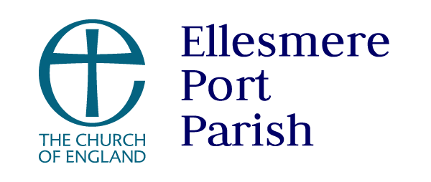

**January 2025 newsletter**

Hello everyone, can you believe here we are in 2025, I wonder what this New Year meant for you, did you enjoy an excuse to party, was it a quiet night in with Joules Holland or was it just another night where you were tucked up in bed by 10.

New year comes around every year and perhaps like me yours have been a mixture of the above. I don't know about you but regardless of it I enter into the whole spirit of New Year there's something about the verse from Philippines chapter 4 that fits so beautifully, it says this;

8Finally, brothers and sisters, whatever is true, whatever is noble, whatever is right, whatever is pure, whatever is lovely, whatever is admirable—if anything is excellent or praiseworthy—think about such things. 9Whatever you have learned or received or heard from me, or seen in me—put it into practice. And the God of peace will be with you.

I encourage all of you to find a moment where you can do this and reflect on your own year, but can I ask you to do it also for the life of our Parish. I have only been here just over six months, but we have so much to be thankful for in the life of the parish. There are so many wonderful things that have been going on especially during the busy season of advent and Christmas, I know myself and Gill are so, very thankful for all that you have done to make this happen, we are certainly giving thanks to God for you!

But that's also in the words of Gill get ‘excited’ together, about the things 2025 may hold for us as a parish.  *Rachel*

Advent was very exciting – lots going on and so much to be thankful for.

We began December with the Christmas fair on a day like no other! The wind howled and the rain came down in torrents but thankfully that did not deter folk from joining us together with the choir from Ellesmere Port Church of England College too! We raised a magnificent total of **£2,733.94.**

36 goody bags were delivered to bereaved folk in the area and were very warmly received by the recipients.

A grand total of  £**1,595.55** was raised from Jonathan’s fundraising evening at St Lawrence.

Our knitters did us proud and approx. 200 Angels of Hope were distributed around the community. One lady who found one on her windscreen wrote to me:

*On Sunday 15th December, my family and I went to a place where I grew up with my brother and mum and dad. It is called the Esplanade in New Ferry, it was a house that you open the front door and the river Mersey greets you. We would take the dogs for walks every day along the shore, when the tide was out. So because it was my mums 75th Birthday yesterday we scattered some of my mums ashes on Sunday so everyone could be there. Then we went to Morrisons for a breakfast as my mum used to love going for a bacon butty there. Then* I *came to the car and found the beautiful Angel of Hope on the windscreen. Words cannot describe how I felt receiving that gift.* A group of gift bags on the floor
*Thankyou Gill for everything and for the gift of the Angel.*

26 bags were delivered to Forum Housing in ‘Giving a Gift for a Stranger’ funds for that was raised through the bacon butty morning £348.50

We enjoyed carol singing in The Port Arcades and were also invited into The Bunbury Arms, Stoak for an evening of carols and curry which was thoroughly enjoyed by all who joined us.

**FIG** have been very active again in December with another successful bag pack. We delivered 197 food bags to 6 local schools which hopefully alleviated the financial burden on some of our families in the community and helped them enjoy the Christmas period.

We were so blessed with the number of volunteers from the community who came to help with the bag pack. Staff from the Co-op joined us again and also provided the bags which were used to carry the goodies. Staff from 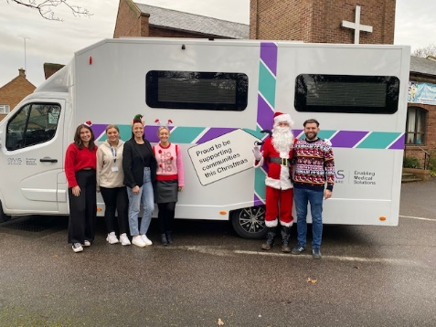EMS joined us and not only that they managed to bring Santa with them who helped with the delivery of the food! Much excitement ensued in the schools when they saw who had arrived as you can imagine. We had a number of students from Ellesmere Port Church of England College who were absolute stars in packing bags but also in helping in putting the church back together again. They were a credit to the school.

One chair of governors wrote to me and said ‘*Families collecting their food bags have been overwhelmed by what they were getting and the gratitude was plain to see. So many said they did not know what they would do without the bags and a few gave hugs and shed a few tears as they collected them. There is absolutely no doubt the difference that they make to families and a few asked if I could pass on their grateful thanks to all involved*. ‘

We hosted a Christmas craft and fun afternoon on 23 December which was well attended and enjoyed by everyone – they all had so many beautiful crafts to take home with them at the end of the day after enjoying a party style tea together. We thank West Cheshire Foodbank for the donation of crisps together with one of our partners Transforming Lives Together who provided lots of snacks and biscuits all of which helps with the cost of hosting these events.

Toms Tots also welcomed Santa and enjoyed a lovely party together before breaking up for Christmas.

We also welcomed in four of our local primary schools to St Thomas for their annual carol/Christingle Service and Rachel spoke at the College’s Christmas service, so many children and young people have heard something of the Christmas story and the message that it brings.

And of course, we welcomed many folk into our churches for the services over the Christmas period.

All of the above would not have been possible without the generosity and love shared by our church family at St Thomas and St Lawrence. On behalf of those on the receiving end of our love a huge thank you to everyone. God has been so good to us as we have been fortunate enough to bless those in our community.

**Date for the diary – 25 January 2025 7pm Burns Night Ceilidh at St Thomas – get those dancing shoes out and ready to have a great night of fun and fellowship. Tickets £10 are now available from Molly Bunnell or Carole Smith. All funds raised will go to the general fund.**

**Dates for January 2025**

|  |  |  |
| --- | --- | --- |
| 5 January | 10.45am | Café church at St Thomas ‘Epiphany’ |
| 6 January | 5pm | What’s Next? In the coffee lounge at St Thomas |
| 8 January | 2pm | Tea at Two in the Coffee Lounge |
| 9 January | 9.30am | Toms Tots re-starts in coffee lounge |
| 14 January | 7.30pm | PCC meeting in coffee lounge |
| 18 January | 2pm | Panto trip to Civic Hall |
| 25 January | 7pm | Burns Night Ceildh |
| 29 January | 10am | Holy Communion at Christ Church School |

Pastoral matters – please do let the clergy or the churchwardens know of any church family members that are sick in hospital or at home and would appreciate a visit.

I think that is it for now. Take care & God bless

Rachel, Gill & the staff team

0759 4277453 Rachel 0785 0122092 Gill 0794 1424215 Ricky