BEACON PROJECT
Donating is simple:
- Scan the QR Code.
- Enter the amount you wish to pay – [Note you will see pay.sumup.com].
- Select Pay as Guest and your chosen payment method.

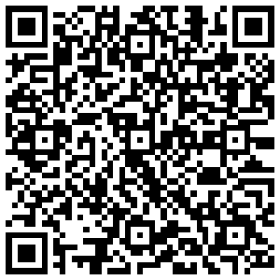

ALL DONATIONS LARGE OR SMALL ARE GRATEFULLY RECEIVED.

